 Through God’s love and strength all flourish  * Achieve * Create * Know  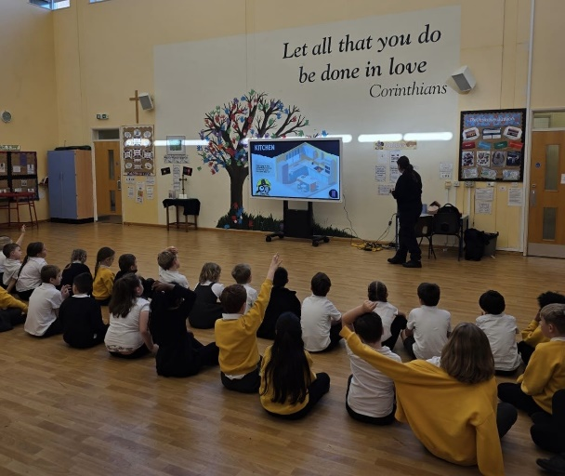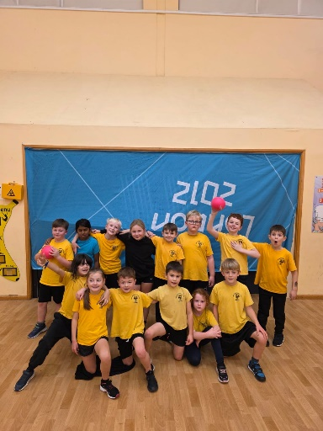 |  |   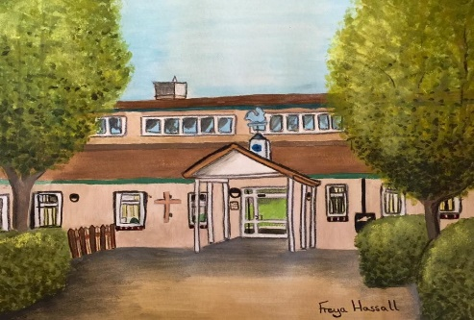  Birthdays to celebrate  Wrens  Robyn W  Magpies  Lydia and Freddie  Owls  Claudia  Hawks  Charlie  Eagles  Teddy  Happy birthday!  
  Friday 28th November 2025 Newsletter Term 2 Week 5
  Dear Parents/Carers
  It is hard to believe that it is December next week and that Sunday is the first Sunday in Advent – our advent table and candles are ready for collective worship. As usual our school has been busy with a learning buzz in all the classes. It was great to see so many of you at the parent/teacher meetings on Tuesday and Wednesday – I hope you found these sessions useful and enjoyed looking through the children’s workbooks.
  Classes enjoyed the fire safety talks on Wednesday, delivered by Kent Fire and Rescue Service. The children had to spot dangers in different rooms of the home, plan escape routes and learnt how to ring 999 in an emergency and what to say. Children were encouraged to check their smoke alarms in their homes – very important life skills.
  On Thursday afternoon, we hosted a dodgeball tournament against St Faith’s for some year 3 and 4 students. The children demonstrated our school values during very competitive games – well done team!
  Have a lovely weekend
  Fiona Crascall
  Headteacher
  Individual school tours for new year R starters 2026 are now available. Applications for Primary Intake opened Friday 7 November 2025. National closing date for application forms is Thursday 15 January 2026
🎉 PTFA Update – 28th November
🎟️ Christmas Raffle Reminder! 🎄
- Raffle tickets are still available to collect from the office — don’t forget to return your stubs and money to the office by Friday 5th December.
- 🎫 Prices: 50p per ticket / £2.50 per book
Extra books are available if you’d like more entries, and unused books can be handed back so others can join in.
- 🛍️ Tickets will also be available to buy at Juliet’s Farm Shop on Sunday 30th November, 10am–2pm.
✨ Fantastic prizes to be won — including a 6ft real Christmas tree, spa experience, zoo tickets & more!
The draw takes place at the Christmas Fair on Friday 5th December.

🍪✨ Calling All Christmas Bakers! 🎄🎅
We need your festive baking magic to make our upcoming event extra special!
📅 Christmas Fair – Friday 5th December
🎂 We’d love donations of nut-free treats such as:
• 🥧 Mince pies
• 🍫 Festive brownies (with dairy-free option if possible)
Your delicious creations will help spread joy and raise funds for our school community.
📩 How to get involved:
Please contact us via Classlist, Facebook, or email us at candk.ptfa@gmail.com.
Thank you for sprinkling a little extra Christmas magic into our events! ❤️

🎄 Ash Cartwright & Kelsey Community Giving Tree 🎁
This year, we're collecting gifts for children aged 0–16 years old to support the wonderful Rainbow Ward at QEQM Hospital.
If you’re able to donate, please bring an unwrapped gift to Reception at Ash Cartwright and Kelsey School by Friday 5th December.
Every donation, big or small, will help bring a smile to a child’s face this Christmas. 🌈💖

Get Involved
Still want to join us? Got great ideas or just want to lend a hand now and then? Whether it’s once a year or more regularly, we’d love to hear from you. Reach out via Facebook, Classlist, or email us at: candk.ptfa@gmail.com
We’re always on the lookout for companies that offer match funding—it’s a fantastic way to boost support for our school. If your employer might offer this, please get in touch!
📬 New this year: We’ve introduced a suggestion box in the school reception area—open to ideas from children and adults alike. Let us know how we can work together to support our school!

📅 Upcoming Events
- 5th December – Christmas Fair + Santa’s Grotto Experience
- 12th December - Festive Tuck Shop
For all the latest updates and school events remember to join us on our Facebook and classlist pages.



Fledglings
Year 1 Robins
Year 2 Magpies
Year 3 Owls
Year 4 Hawks
Year 5 Eagles
Year 6 Falcons



Week Ending
28/11/2025

Dates for your diary
Friday 5th December | Christmas Fayre after school
Tuesday 9th December | Christmas jumper day and school Christmas dinner
Thursday 11th December | i-rock concert at 9.30am in school hall
Tuesday 16th December | EYFS nativity to parents at 1.45pm
Wednesday 17th December | KS1 nativity to parents at 1.45pm
Thursday 18th December | End of term 2 – Christmas service at the Church at 1.45pm. Parents of year 6 are very welcome
Friday 19th December | INSET day – no children in school
Monday 5th January | INSET day – no children in school
Tuesday 6th January | Children back in school for WOW day!
Monday 12th January | Arts week in school – theme is spirituality
Thursday 15th January | Mid year reports to parents
Friday 6th February | Year 6 to Harry Potter World
Friday 9th February | Children’s Mental Health Week – Theme is ‘This is my place’- focus on belonging
Wednesday 11th February | Safer Internet Day
Friday 13th February | End of term 3
Friday 23rd February | Children back in school for term 4

